**Lowland Results**

Date Range of Independent Detections: (1/1/2012 - 9/9/2018)

Lowland Species List

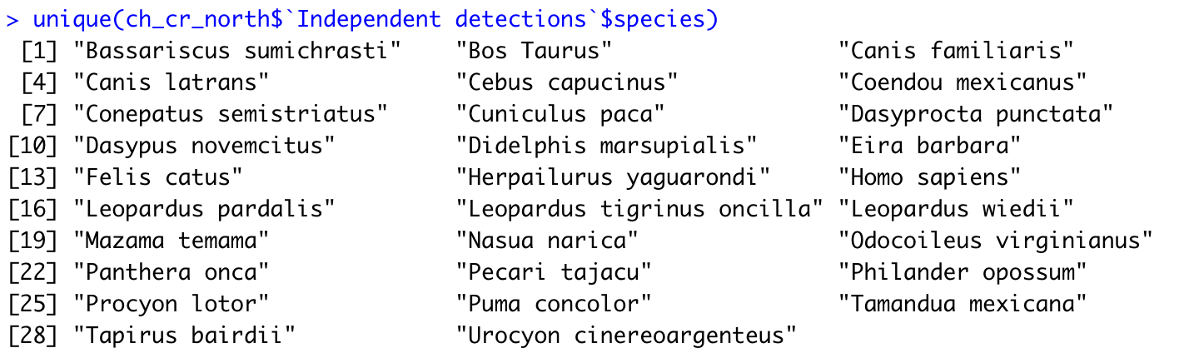

Puma Occupancy → probability of occupancy = 0.5574946; detection = 0.3307046 (from the null model)

Univariate AIC Table: Net Primary Productivity best model on occupancy

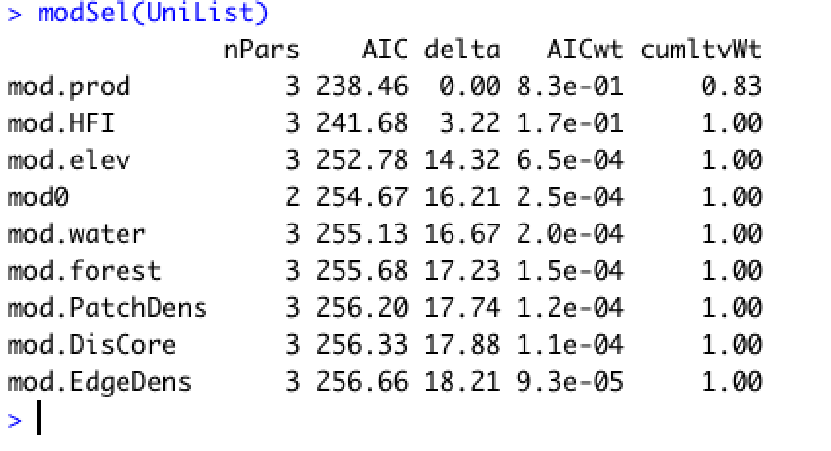

Multivariate AIC Table: HFI + Elevation best model, mod.HFI is the only significant model ( p - value = 0.0399)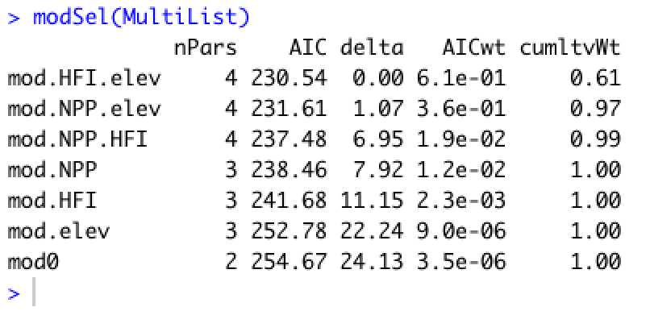

Paca → probability of occupancy = 0.49675; detection = 0.5426461 (from the null model)

Univariate AIC Table: HFI best model

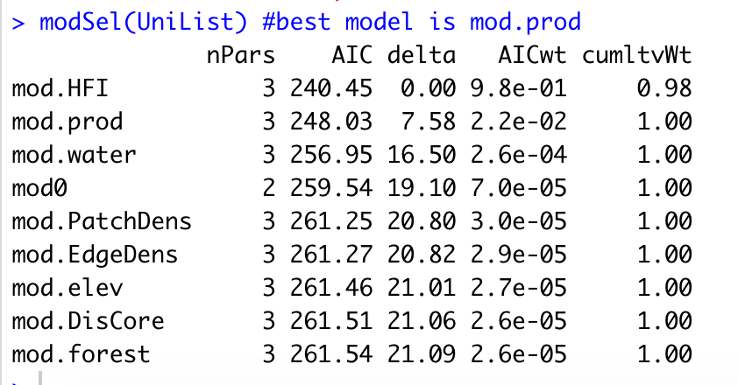

Multivariate AIC Table: HFI best model, Productivity and HFI, and HFI and water index both equally supported; none are significant

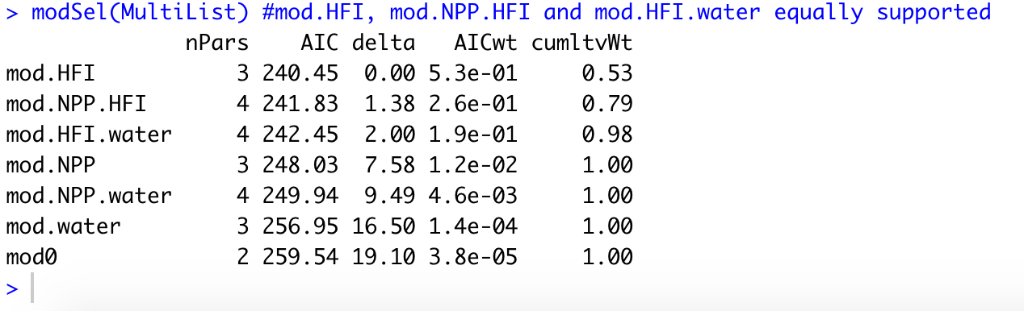

Peccary→ probability of occupancy = 0.8442242; detection = 0.4311894 (from the null model)

Univariate AIC Table: HFI best model

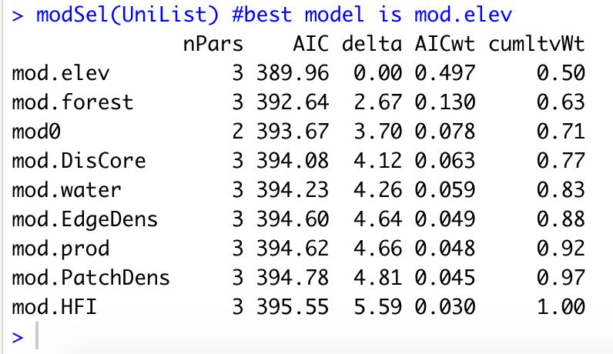

Multivariate AIC Table: Elevation + Forest is best model with Elevation being equally supported; none are significant

